Table of Contents

Links 1

Using the Workflow analyzer 1

What is workflow analyzer 1

Why you need Workflow Analyzer 2

How does Workflow Analyzer work? 2

Workflow Analyzer rules categories-Configuring the rules 3

# Links

# Using the Workflow analyzer

Workflow Analyzer is a feature used to ensure that the automation projects created by you and your colleagues in Studio to follow the same set of automation best practices and to enforce governance.

## What is workflow analyzer

Workflow Analyzer is a static code analyzer that ensures your project meets high quality and reliability standards.

When triggered, the Workflow Analyzer uses the configured rule set to check the project or workflow for inconsistencies without executing the project. It logs the errors found in the Error List panel, under the rule action (Error, Warning, Info or Verbose). The rules are based on UiPath Automation Best Practices.

Using the Workflow Analyzer, you can:

* Edit, disable and enable rules from Studio.
* Run validation or validation and analysis at file or project level.
* Manage errors and warnings in the Error List panel.
* Build custom rules using the UiPath.Activities.Api package.
* Integrate workflow analysis with prebuilt and/or custom rules in CI/CD pipeline configurations.

## Why you need Workflow Analyzer

Workflow analysis plays a central part in project development. Workflow Analyzer is a tool for making sure your project follows best practices, thus ensuring higher quality, reliability and readability.

It is also used to enforce governance policies using file-based governance and UiPath Automation Ops.

## ****How does Workflow Analyzer work?****

You can access the Workflow Analyzer options by clicking the **Analyze File** drop-down menu from the Design ribbon tab. Running workflow analysis is a two step process. The Analyzer runs workflow validation (checks for compilation errors) first, and only after it passes, it analyzes (checks for breaches against the define Workflow Analyzer rules) the workflow.

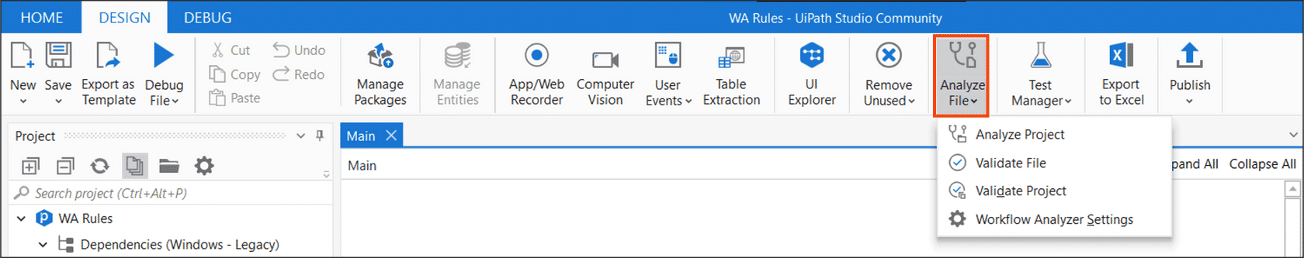

The Workflow Analyzer works based on rules and each rule has a default action level based on its criticality. The action levels per rule can be set to **error, warning, info or verbose**. The workflow analyzer can be configured to block publishing or running the process if it encounters an **error**level breach during analysis.

The workflow analyzer can be enforced using two ways:

* **Enforce analyzer before run:**This option runs the Workflow Analyzer before running or debugging a workflow file and checks for all the rules with**Error**action. It allows execution of the workflow only if no errors are found.
* **Enforce analyzer before publish:**This option runs the Workflow Analyzer before publishing a workflow file or a project. It checks for all the enabled rules regardless of their action and allows publishing only if there are no rule violations with the action **Error.**

To enable either of these options, access Home > Settings > Design.

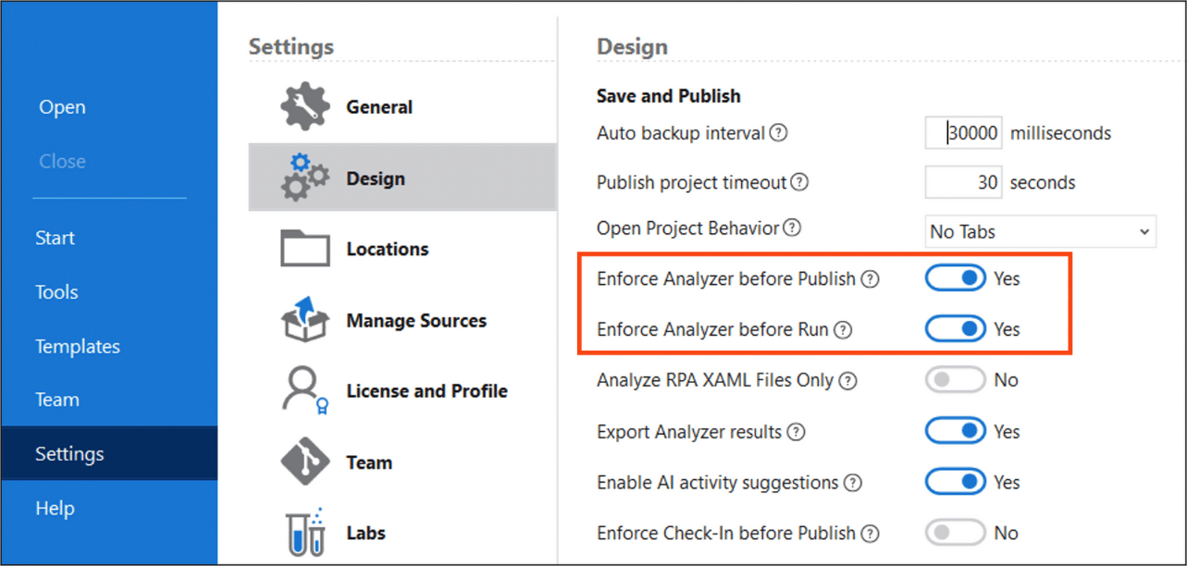

## ****Workflow Analyzer rules categories-Configuring the rules****

In the analysis stage, your project is checked against a set of predefined rules applicable to Studio. At the moment, there are eight rule categories:

1. Naming rules:

Rules in this category carry the **NMG** code in their ID. This category checks the file or project for any inconsistencies related to naming.

Below is the list of rules:

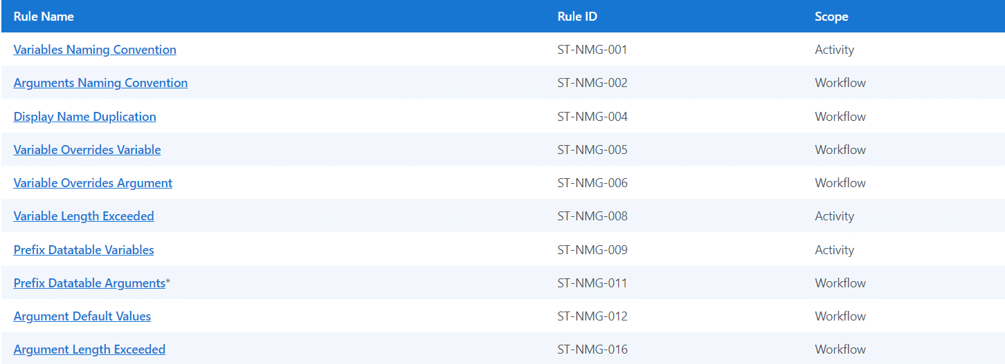

1. Design Best Practices:

Rules in this category contain the **DBP** code in their ID. This category refers to requirements for ensuring your project meets a general set of best practices.

Below is the list of rules: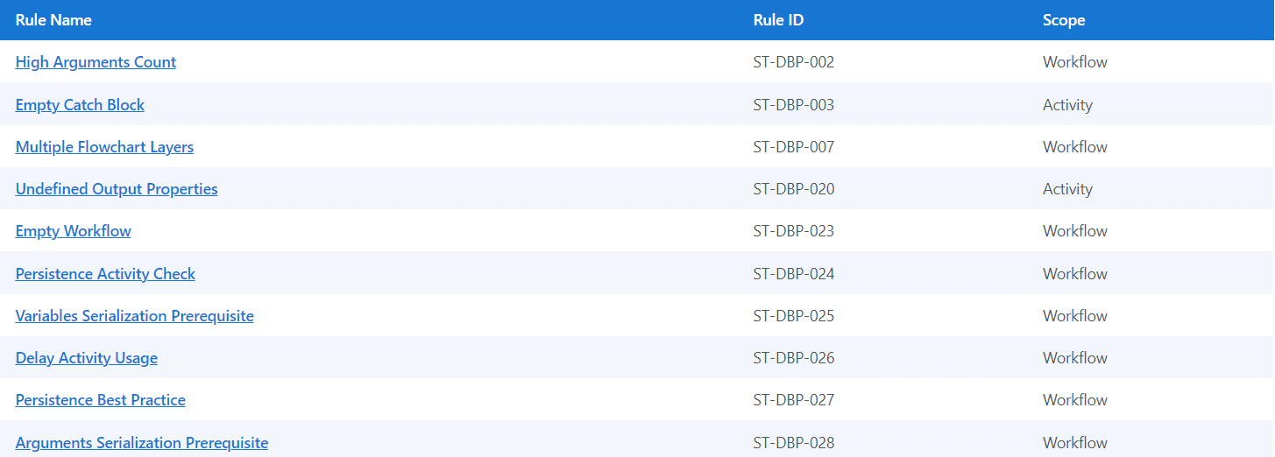

1. Project Anatomy Rules:

Rules in this category contain **ANA** code in their ID. The rules in this category ensure your project meets general requirements in terms of anatomy.

Below is the list of rules:

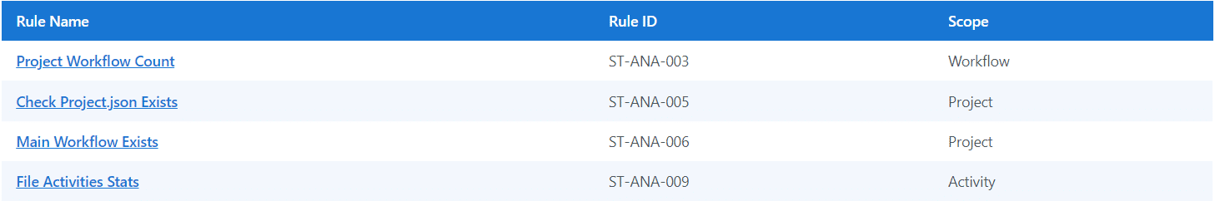

1. Maintainability & Readability

Rules in this category contain **MRD** code in their rule ID. The rules in this category require projects to be easy to understand so that maintainability is ensured.

Below is the list of rules:

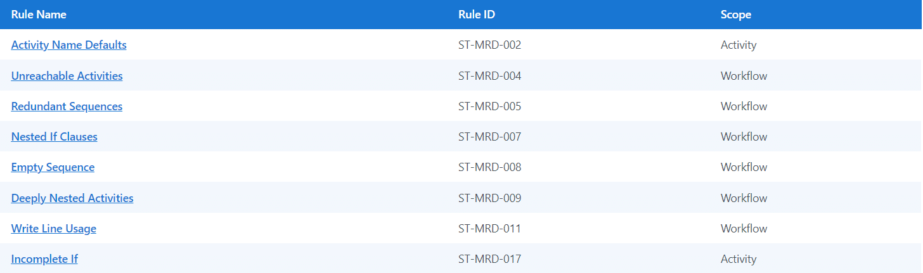

1. Usage Rules:

Rules in this category contain **USG** code in their ID. The rules in this category refer to requirements for ensuring elements defined in your project are actually used.

Below is the list of rules:

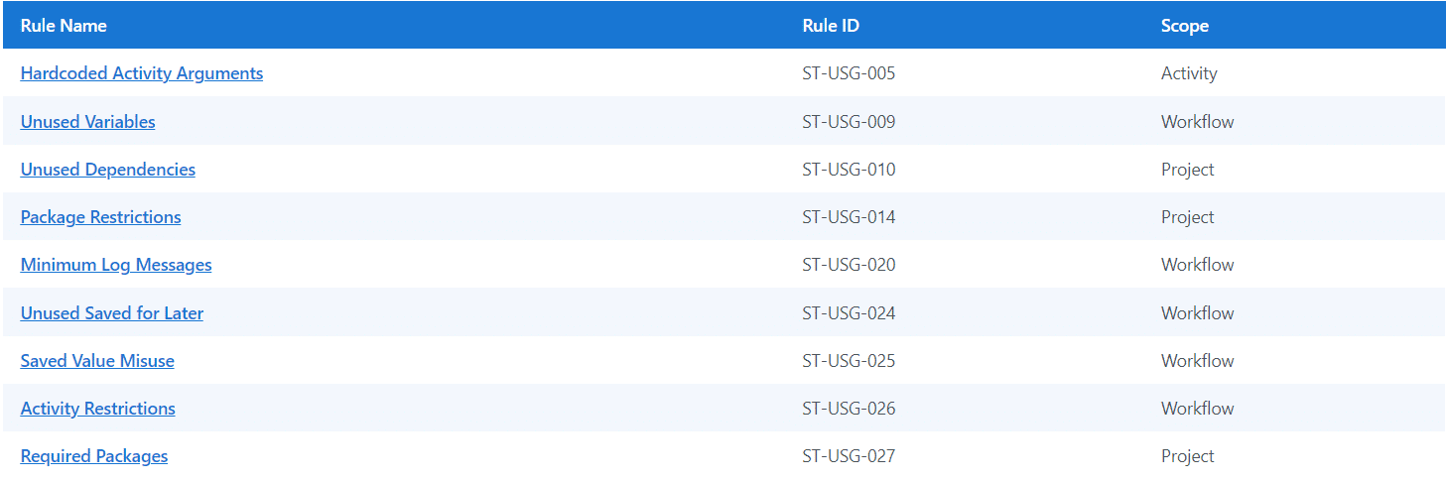

1. Performance & Reusability:

A rule in this category contains **PRR** code in its ID. The rule in this category checks the file or project for any inconsistencies related to performance and reusability.

Below is the rule:



1. Reliability Rule:

A rule in this category contains **REL** code in its ID. The rule is in this category checks the file or project for any inconsistencies related to reliability.

Below is the rule:



1. Security Rules:

The rules in this category contain **SEC** code in their ID. The rules in this category check the file or project for any inconsistencies related to security.

Below is the list of rules:

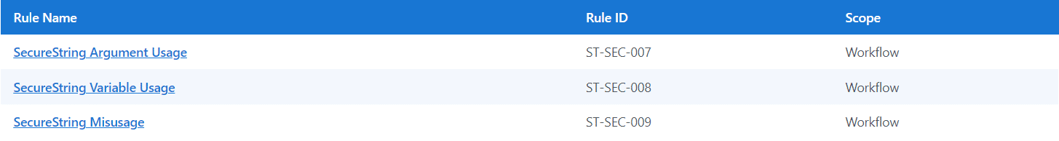

Please note that the categories and rules under each category may be updated with various releases. Do refer to the documentation page in the Workflow Analyzer section of the UiPath Studio Guide to stay updated.

Also, certain activity packages such as Excel, Mail, Testing, and UI Automation will come with their own workflow analyzer rules. These rules will get added automatically when your workflow uses any of these activity packages.

## ****Workflow Analyzer rules components****

Each rule has an ID, name, description, recommendation, scope and default action. Some rules have an editable property.

Let us have a quick look at each component of the rule.

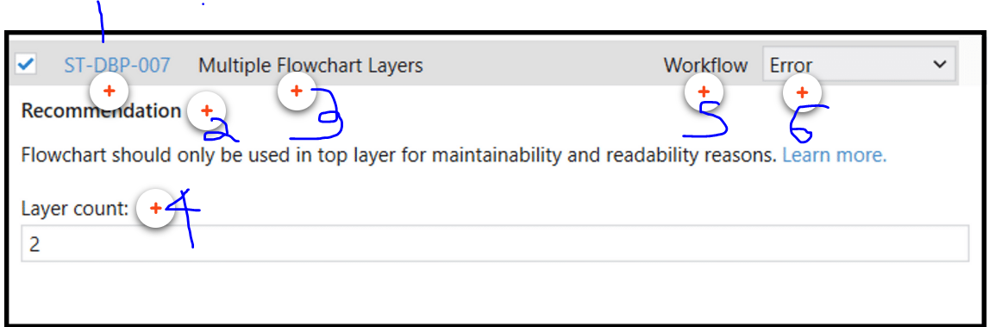

1. ID

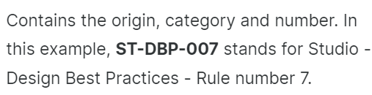

1. Recommendation

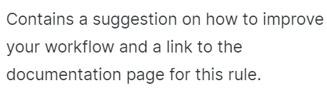

1. Name:

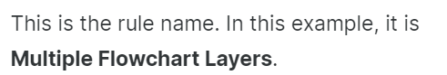

1. Editable properties:

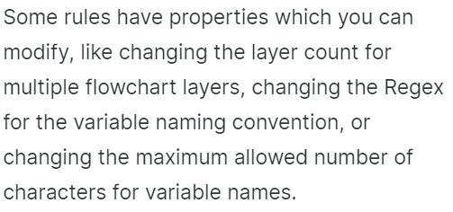

1. Scope:

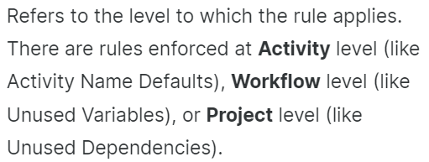

1. Default action:

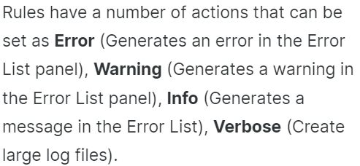

Note that if you have changed any default parameters and want to revert then right-click the selected rule and select **Reset to Default**option.

**Exporting Workflow Analyzer results**